INSIGHTSTREAM :NAVIGATE TO THE NEWS LANDSCAPE
(React Application)

TEAM LEADER
B.LOGESH
EMAIL : logeshbhaskaran2@gmail.com
TEAM MEMBERS
M.POOVARASAN
EMAIL : kingflower698@gmail.com
B.LOGESH
EMAIL : smlogesh100@gmail.com
N.LOKESH
EMAIL : Chandruneelamegan@gmail.com
S.MANIKANDAN
EMAIL : manikandansasi0018@gmail.com

INTRODUCTION :
Insight Stream is a revolutionary web application designed to redefine how people discover and consume news. It offers an intuitive interface, dynamic search, and a vast range of news categories for all types of users. Join Insight Stream to embark on an informative journey and experience the future of news consumption.
PROJECT OVERVIEW :
🌐 Welcome to the cutting-edge frontier of news exploration with Insight-stream! Our revolutionary web application is meticulously crafted to transcend the boundaries of traditional news consumption, catering to the diverse interests of both avid news enthusiasts and seasoned information professionals. With an emphasis on an intuitive user interface and a robust feature set, Insight-stream is poised to redefine the entire news discovery and consumption process.

📰 Designed with a commitment to user-friendly aesthetics, Insight-stream immerses users in an unparalleled journalistic adventure. Navigate seamlessly through a vast expanse of news categories with features such as dynamic search, effortlessly bringing you the latest and most relevant stories from around the world.

🌍 From those seeking the latest headlines to seasoned news connoisseurs, Insight-stream embraces a diverse audience, fostering a dynamic community united by a shared passion for staying informed. Our vision is to reshape how users interact with news, presenting a platform that not only delivers breaking stories but also encourages collaboration and sharing within the vibrant news community.

📡 Embark on this informative journey with us, where innovation seamlessly intertwines with journalistic tradition. Every click within Insight-stream propels you closer to a realm of global happenings and perspectives. Join us and experience the evolution of news consumption, where each feature is meticulously crafted to offer a glimpse into the future of staying informed.

🌐 Elevate your news exploration with Insight-stream, where every headline becomes a gateway to a world of information waiting to be discovered and understood. Trust Insight-stream to be your reliable companion on the journey of staying connected with the pulse of the world.

PURPOSE :

The primary objective of Insight-stream is to establish a user-friendly platform tailored for individuals who are passionate about staying informed, exploring diverse news topics, and accessing the latest updates.

Our Key Goals Include:

✔ User-Friendly Experience: Develop an interface that is intuitive and easy to navigate, ensuring users can effortlessly access, save, and share their preferred news articles.

✔ Comprehensive News Management: Provide robust features for organizing and managing news content, incorporating advanced search options for a personalized news experience.

✔ Technology Stack: Employ cutting-edge web development technologies, such as React.js, to ensure an efficient and enjoyable user interface.

FEATURES :

✔ News from API Sources: Access a vast library of global news spanning various categories and interests, ensuring a well-rounded coverage of current affairs.

✔ Visual News Exploration: Discover breaking stories and explore different news categories through curated image galleries, enhancing the visual appeal of news discovery.

✔ Intuitive Design: Navigate the application seamlessly with a clean, modern interface designed for optimal user experience and clarity in information presentation.

✔ Advanced Search Feature: Easily access news articles on specific topics through a powerful search feature, providing users with tailored news content based on their interests.

ARCHITECTURE :
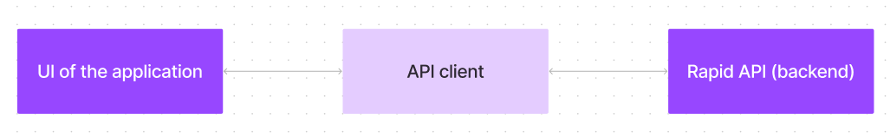

The user experience starts with the Insight-stream web application's UI, likely built with a framework like React or vue.js for a smooth, single-page experience. This UI interacts with an API client specifically designed for Insight-stream. This client handles communication with the back-end, but with a twist: it leverages Rapid API, a platform providing access to various external API s. This suggests Insight-stream might integrate external data feeds or functionalities through Rapid API, enriching the user experience without building everything from scratch.
Component Structure:
The React front-end is divided into multiple reusable components such as Navbar, News Cards, Search Bar, and Category Filters to ensure modular development.

State Management:
State management is handled using React Context API. The global state stores user preferences, news articles, and search results, allowing a seamless experience across different pages.

Routing:
React Router is used for client-side navigation, ensuring smooth transitions between pages without reloading.

SETUP INSTRUCTIONS :

- PREREQUISITES :

✔ Node.js and npm:

Node.js is a powerful JavaScript runtime environment that allows you to run JavaScript code on the local environment. It provides a scalable and efficient platform for building network applications.

✔ React.js:

React.js is a popular JavaScript library for building user interfaces. It enables developers to create interactive and reusable UI components, making it easier to build dynamic and responsive web applications.

- INSTALLATION :

✔ Clone the repository: git clone [repository link]
✔ Navigate into the project folder: cd news-app-react
✔ Install dependencies: npm install
✔ Start the development server: npm start
✔ Open the application in a browser: HTTP://local host:3000

FOLDER STRUCTURE :

The project follows a structured organization with separate directories for different functionalities:

- ✔ Components: Contains all reusable UI components like Navbar, News Cards, and Search Bar.
- ✔ Pages: Includes screens such as Homepage, Category Page, and Article Detail Page.
- ✔ Context: Holds the global state management logic using React Context API.
- ✔ Styles: Stores all CSS files and styling resources.
- ✔ Utils: Contains helper functions, such as API call handlers.

RUNNING THE APPLICATION :

To start the front-end development server locally, execute the following command:

- npm start

After the application starts, access it in a browser using:

- http://localhost:3000

COMPONENT DOCUMENTATION :

- ✔ Navbar: Provides site navigation, including links to categories.
- ✔ Hero Section: Displays trending news with headlines and images.
- ✔ News Cards: Displays individual news articles with summary and source link.
- ✔ Search Bar: Enables keyword-based article searching.
- ✔ Footer: Contains links to social media and additional information.

STATE MANAGEMENT :
The application uses the React Context API to manage global state efficiently.
Global State:
✔ Stores user preferences, fetched news articles, and search queries.
Local State:
✔ Manages component-specific states such as form inputs, UI interactions, and loading states.

USER INTERFACE :
The UI is designed to be intuitive and responsive, ensuring a smooth experience across devices.
✔ Dark and Light Mode toggle feature for better readability.
✔ Mobile-friendly layout with optimized touch interactions.
✔ A clean and modern UI built with Bootstrap and Tailwind CSS.

STYLING :
The application uses a combination of modern CSS techniques for styling:
✔ Bootstrap for pre-built UI components.
✔ Tailwind CSS for custom styling and layout enhancements.
✔ Responsive design ensuring optimal performance on all screen sizes.

TESTING :
The project follows a structured testing strategy:
- ✔ Unit Testing: Individual components tested using Jest and React Testing Library.
- ✔ Integration Testing: API calls and state updates verified.
- ✔ UI Testing: Ensuring the responsiveness and layout integrity.

CODE COVERAGE :
Important Code snips:
With the API request, we fetch the trending news articles.

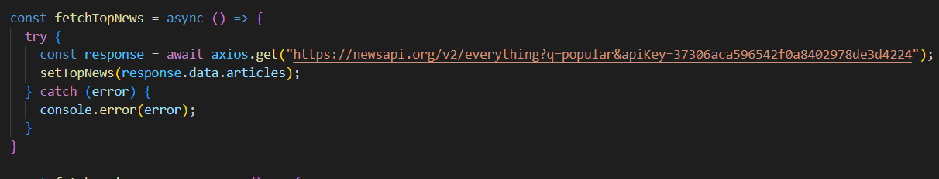

The code snippet shows a function written in Python called fetchTopNews that
fetches news articles from an API. Here's a breakdown of the code:
Async function fetchTopNews:
The code defines an asynchronous function named fetchTopNews. An
asynchronous function is used to handle asynchronous operations, such as making
API requests that take time to complete.

try...catch block:

● The try...catch block is used to handle the API request.
● The try block contains the code that attempts to fetch data from the API using
axios.get.
● axios is an external Python library for making HTTP requests. If you don't
already use Axios in your project, you'll need to install it using a package
manager like pip.
● The .get method makes a GET request to the specified URL.

API URL:
The URL used in the API request is
'https://newsapi.org/v2/everything?q=popular&apiKey=37306aca596542f0a840297
8de3d4224'.
This is likely a specific API endpoint that returns popular news articles. You might
need to replace this URL with the actual endpoint you want to use depending on the
API you're using. Replace '37306aca596542f0a8402978de3d4224' with a placeholder
instructing users to replace it with their own API key.

Error Handling (catch block):

The catch block handles any errors that might occur during the API request. If there's
an error, it's logged to the console using console.error(error).

Setting State (then block not shown):
The .then method (not shown in the code snippet) is likely used to process the fetched data after a successful API request.In this case, it likely updates a state variable named topNews (based on the function name fetchTopNews) with the fetched news articles.
Fetching news by search/category :

With the specific category or search keyword, we use API request to fetch all the
news articles related to that.

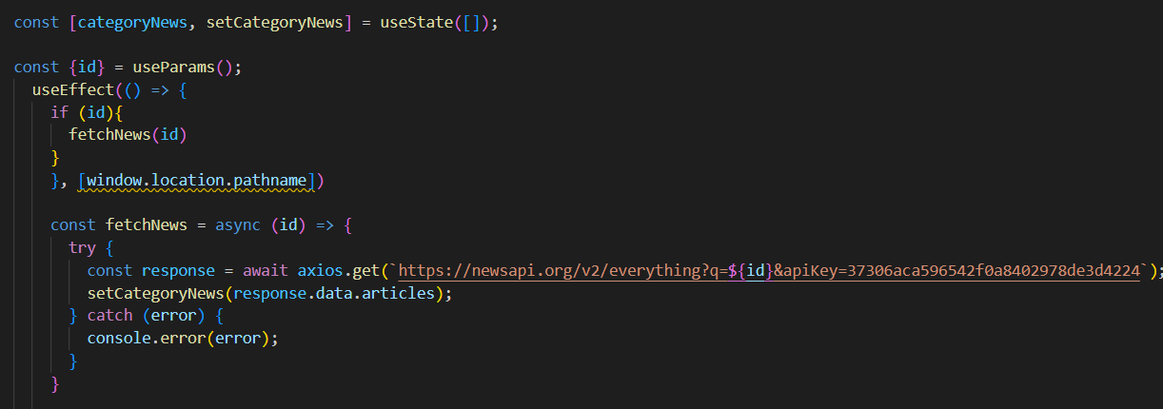

The code snippet shows a function called get_news_articles that fetches news
articles from a news API. Here's a breakdown of the code:
Imports:
The code starts by importing the requests library. The requests library is a popular
Python library for making HTTP requests. If you don't already have it installed in your
project, you can install it using pip install requests.
API Key:
The line API_KEY = 'YOUR_API_KEY' defines a variable named API_KEY and assigns it
a placeholder value 'YOUR_API_KEY'. You should replace this with a placeholder
instructing users to replace it with their own API key obtained from the news API
provider they want to use.
Function Definition (get_news_articles):
The code defines a function named get_news_articles that takes two parameters:
● query: This parameter is likely a string representing the search query for news
articles.
● source: This parameter is likely a string representing the news source (e.g.,
'bbc-news', 'cnn').

Building the API Request URL:
The line url = f'https://newsapi.org/v2/everything?q={query}&apiKey={API_KEY}'
constructs the URL for the API request using a formatted string literal (f-string).
The URL includes the following parts:
● Base URL: https://newsapi.org/v2/everything● Query parameters:
● q: This parameter is set to the query argument passed to the function.
● apiKey: This parameter is set to the API_KEY variable, which should
contain the user's API key.
Making the API Request (requests.get):

The line response = requests.get(url) sends a GET request to the API URL constructed
earlier. The requests.get function from the requests library is used to make the HTTP
request. The response from the API is stored in the response variable.

Error Handling (try...except block):

● The try...except block is used to handle potential errors during the API
request.
● The try block contains the code that attempts to fetch data from the API using
requests.get(url).
● The except block handles any exceptions that might occur during the request,
such as network errors or invalid API responses. In this case, it prints an error
message to the console using print(error fetching news articles: {e}').

SCREENSHOTS :
After completing the code, run the react application by using the command “npm start” or “npm run dev” if you are using vite.js
Here are some of the screenshots of the application.
Hero components :
In the hero component, the trending news articles are displayed. It is to highlight
them. Apart from that, the search bar is also available to search for various
articles and categories.

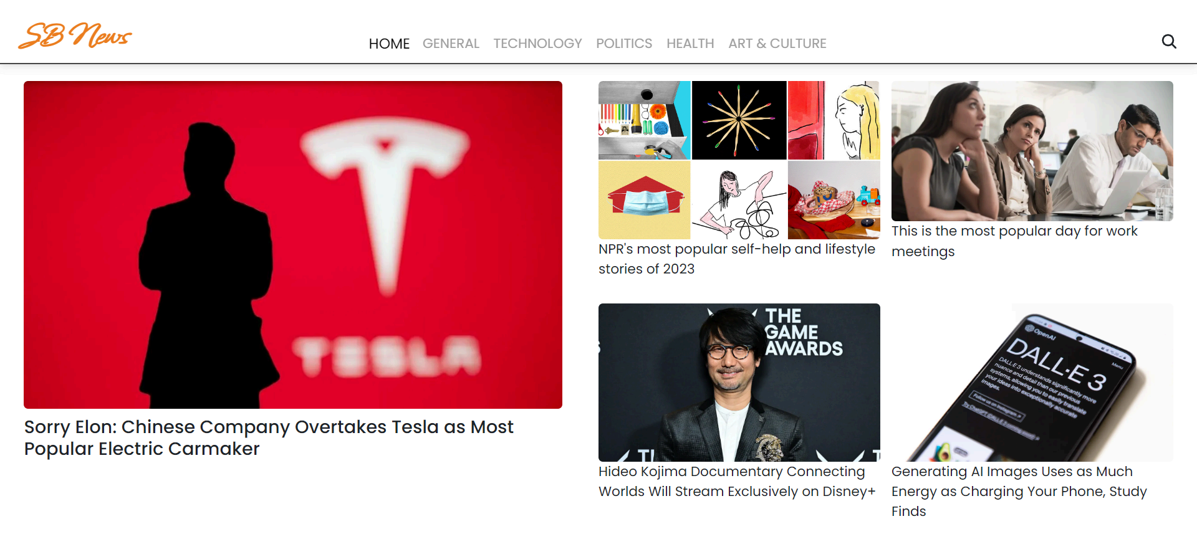

Popular categories :
In the hero component, the trending news articles are displayed. It is to
highlight them. Apart from that, the search bar is also available to search for
various articles and categories.

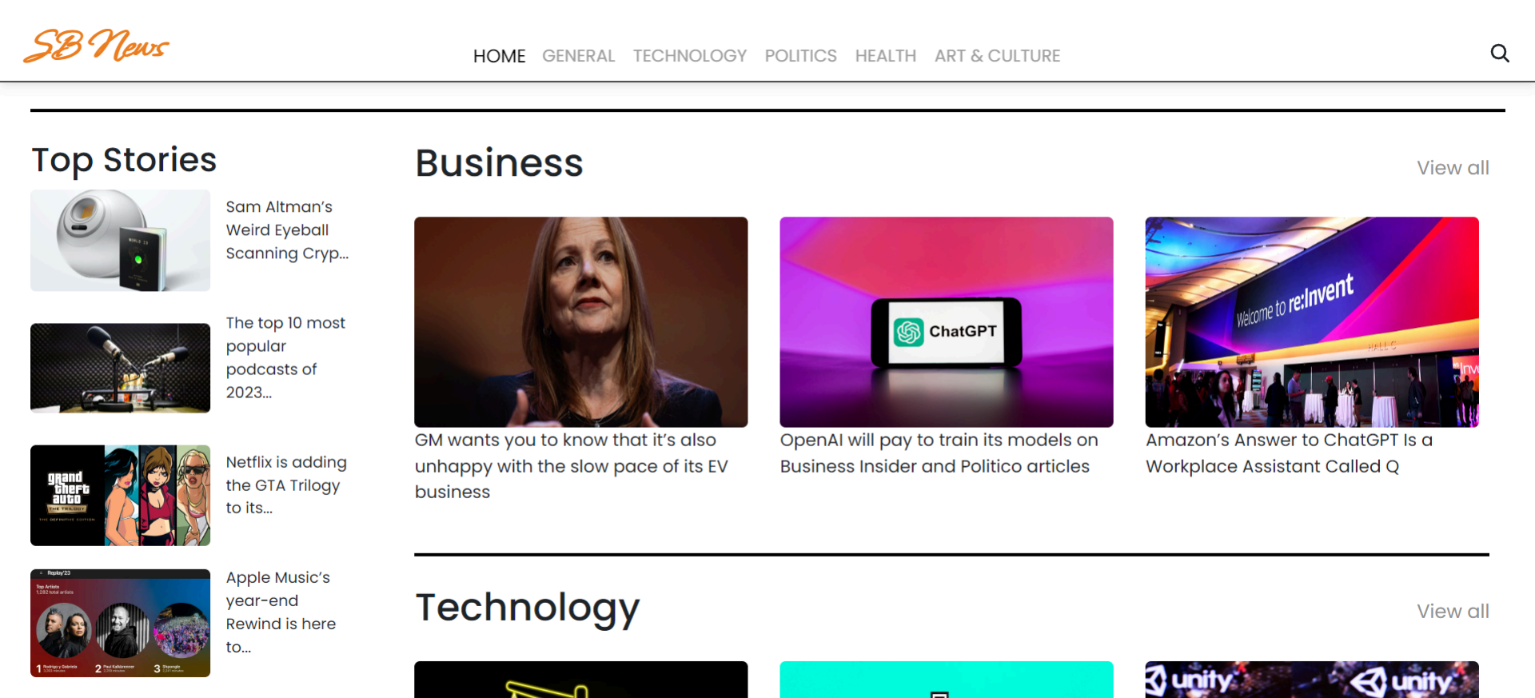

Newsletter :
Staying informed is key! This section would act as a magnet for users who want
to stay up-to-date on the latest news. A brief sign up form with an email field
would be presented, along with a clear call to action button like "Subscribe Now"
or "Get Daily News Updates." With a simple click, users can join the
Insight Stream community and receive curated news delivered straight to their
inbox.
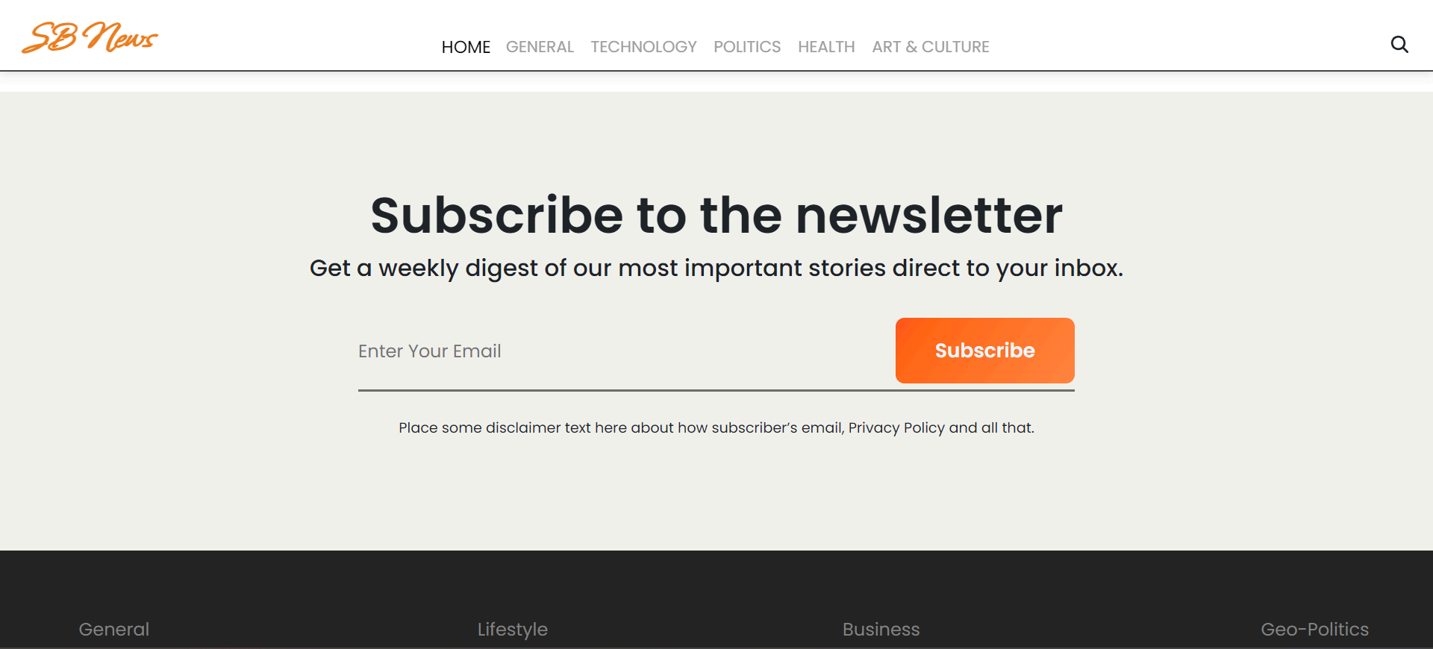

Category/Search result page :
Finding the news you crave is effortless with Insight Stream. This page displays a
neatly organized list of articles matching your chosen category or specific search
query. Each entry would provide a clear headline, a concise summary, and if
available, an image to give you a quick glimpse into the story. To further refine your exploration, filters or sorting options might be available. Imagine narrowing down results by date, source, keyword, or other relevant criteria to pinpoint exactly what you are looking for,
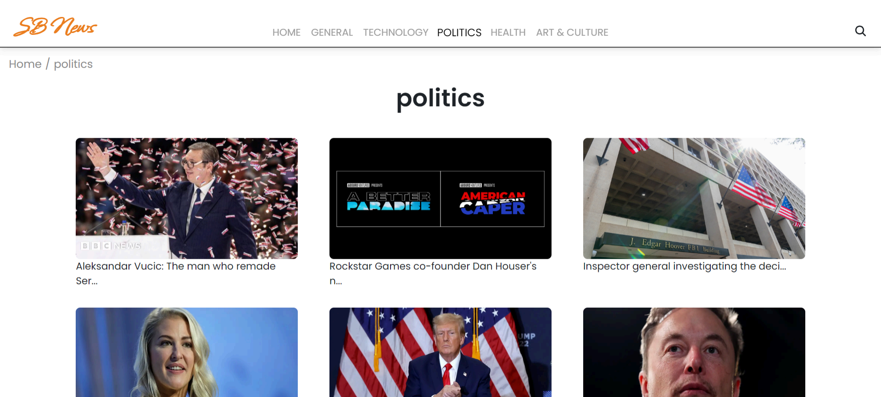

Redirected Article page :
This is where you dive deep! The article page proudly displays the complete
news story, retrieved directly from the original source. To keep you engaged and
exploring related topics, the page might also suggest additional articles based on
the current story. These suggestions can open doors to a world of interconnected
information, allowing you to become a well-rounded news connoisseur.



FUTURE ENHANCEMENTS :
- ✔ Implement user authentication and profiles.
- ✔ Enhance search functionality with AI-based recommendations.
- ✔ Improve caching mechanisms for faster news retrieval.
- ✔ Add support for multi-language news feeds.
- ✔ Introduce push notifications for breaking news.

